**Assignment – July 20**

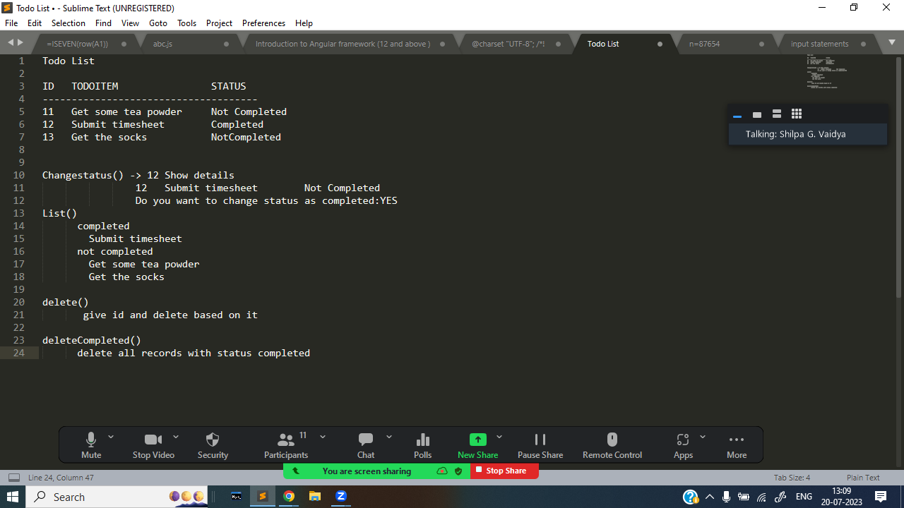

**var inputArray = [**

**{**

**id:10,**

**todoItem:"Get some tea powder",**

**status:"Not Completed",**

**},**

**{**

**id:20,**

**todoItem:"Submit timesheet",**

**status:"Not Completed",**

**},**

**{**

**id:30,**

**todoItem:"Get the socks",**

**status:"Not Completed",**

**}**

**]**

**function changeStatus(){**

**var id=prompt("provide id");**

**id=parseInt(id);**

**var item=inputArray.filter(x=>x.id===id);**

**console.log("ITEM :",item);**

**if(item[0]["status"]=="Not Completed"){**

**var yesOrNO=prompt("Do you want to change the status : choose yes or no :");**

**if(yesOrNO==="yes"){**

**item[0].status="Completed";**

**}**

**}**

**console.log("Item after changing",item);**

**var index=inputArray.findIndex(x=>x.id===id);**

**inputArray[index]=item[0];**

**console.log("AFTER updating status ",inputArray);**

**}**

**function list(){**

**const completedList=inputArray.filter(x=>x.status==="Completed");**

**console.log("Completed List",completedList);**

**const notCompletedList=inputArray.filter(x=>x.status!=="Completed");**

**console.log("NOT Completed List",notCompletedList);**

**}**

**function Delete() {**

**let delval = parseInt(prompt("Enter the Id to delete values"))**

**let index = inputArray.findIndex(list => list["id"] === delval)**

**if (index == -1) {**

**console.log("Id not found. No record deleted.");**

**}**

**else {**

**let dellist = inputArray[index]**

**let yes = prompt(**

**`Do you want to delete the following record?\n\nId: ${dellist["id"]}\nTodoItem: ${dellist["todoItem"]}\nStatus: ${dellist["status"]} \n y/n?`**

**);**

**if (yes === "y") {**

**inputArray.splice(index, 1);**

**console.log("Record Deleted successfully!");**

**} else {**

**console.log("Deletion canceled.");**

**}**

**}**

**}**

**function deleteRecordsStatusCompleted(){**

**for(let i=0;i<inputArray.length;i++){**

**if(inputArray[i]["status"]==="Completed"){**

**inputArray.splice(i,1)**

**}**

**}**

**console.log("Deleted All records with Status COmpleted")**

**}**

**function main(){**

**let choice;**

**while (true) {**

**console.log("1. Change 2. list 3. Delete 4. DeleteAllRecords 5. Exit");**

**choice = parseInt(prompt("Enter the choice"));**

**if (choice === 5) {**

**break;**

**}**

**switch (choice) {**

**case 1:**

**changeStatus();**

**break;**

**case 2:**

**list();**

**break;**

**case 3:**

**Delete();**

**break;**

**case 4:**

**deleteRecordsStatusCompleted();**

**break;**

**default:**

**console.log("Invalid Choice");**

**}**

**}**

**}**

**main();**